**UNIVERSITY OF GREENWICH**

COMP1649

–

Human Computer Interaction and Design

Coursework

Interaction and Design

|  |  |
| --- | --- |
| Student | **Truong Van Tuan Kiet** |
| ID number | **001353327** |
| Supervisor | **Bui Dang Ha Phuong** |
| Student submission date | **24 November 2023** |

**Table of Contents**

Table of Contents 2

Table of Figures 3

Table of Tables 4

1 Introduction 5

2 Background literature 5

2.1 HCI Research 5

2.2 HCI Theory 7

3 Design Process 10

3.1 Conceptual Design 10

3.2 Design principles 12

4 Prototype 13

4.1 Low-fidelity prototype 13

4.2 Mid-fidelity prototype 16

5 Research Study 27

4 Conclusion 29

References 31

Appendices 1 - The questionnaires in the Survey of users about TK DIVE aplication 32

Appendices 2 - Analyze the results of the questions in the survey and draw conclusions for each hypothesis that has been raised. 35

**Table of Figures**

Figure 1. Divemate 5

Figure 2. Deepblu 6

Figure 3. Dive+ 6

Figure 4: Hierarchical model 10

Figure 5. Conceptual model 11

Figure 6. Login low-fidelity prototype 13

Figure 7. Register low-fidelity prototype 13

Figure 8. Tracking history low-fidelity prototype 14

Figure 9. Taking photos low-fidelity prototype 14

Figure 10. Tacking videos low-fidelity prototype 15

Figure 11. Tracking low-fidelity prototype 15

Figure 12: Login design 16

Figure 13: Wrong username or password 16

Figure 14: "Create your account now" link 17

Figure 15: Register design 17

Figure 16. Error message of Register Design 18

Figure 17:Home page design 18

Figure 18: Tracking history design 19

Figure 19. Track detail 19

Figure 20: Add new Track 20

Figure 21. Delete Track 21

Figure 22: Add new track design 21

*Figure 23. TakingPhotos design* 22

Figure 24: Tacking videos design 22

Figure 25: Gallery design 23

Figure 26: Setting design 23

Figure 27. Edit user profile 24

Figure 28. Edit profile successfully 24

Figure 29. Change Password 25

Figure 30: Help user design 25

Figure 31. About app design 26

Figure 32. Frontal physical prototype 26

Figure 33. Side physical prototype 27

Figure 34. Question 1 of the Survey 35

Figure 35: Question 2 of the Survey 35

Figure 36. Question 3 of the Survey 36

Figure 37. Question 3 of the Survey 36

Figure 38. Question 5 of the survey 37

Figure 39. Question 6 of the survey 37

Figure 40. Question 6 of the survey 38

Figure 41. Question 8 of the survey 38

# Table of Tables

Table 1. Metaphors 11

Table 2: Hypotheses Questions 28

# Introduction

Entering the deep-sea world and discovering magical underwater experiences has become a passion and hobby for many people. Surface diving and hobby diving enthusiasts are looking for new interactive tools to track parameters such as (current) depth, time to surface, amount of gas remaining in the tank, time diving, etc. during their scuba diving journey, capturing, and enjoying every precious moment under the sea.

This project set out to develop an interactive mobile application, specifically designed for professional and amateur divers. This app provides the ability to take underwater photos and videos through a wearable device to record great diving trips, while also tracking and recording diving activity details.

# Background literature

## **HCI Research**

* **DiveMate**

This app lets divers easily document their diving experiences via pictures, videos, and notes. You can also connect your dive computer and transfer your dive data from your smartphone or tablet. The app works even when there is no internet connection, and you can save many online maps for offline use (Divemate, 2023).

Figure 1. Divemate[1]

* **Deepblu**

This app is an intuitive dive log app that lets divers discover dive sites and plan dive travel based on user reviews. You can also book dives directly by communicating with local dive shops via Deepblu. Deepblu creates dive logs automatically by syncing with your dive computer via Bluetooth. You can also attach pictures and videos to your dive logs and share them with other divers on the platform (Deepblu, 2023).

Figure 2. Deepblu[2]

* **Dive+**

This app is a powerful photo and video editor for divers. It can automatically correct the color and contrast of your underwater images and videos, making them more vivid and realistic. You can also add filters, stickers, frames, and text to your media and share them with your friends on social media. The app also has a smart identification feature that can recognize the marine life in your photos and videos and provide you with information about them (Dive Plus, 2023).

Figure 3. Dive+[3]

## **HCI Theory**

* + 1. **Interaction design principles and interaction design patterns**
* **Definition of Interaction Design:** According to (Norman, 2014), Interaction design (IxD) is a creative and research-based process of designing interactive products, services, and systems that meet the needs of users. IxD focuses on understanding how users interact with technology and using this knowledge to create experiences that are both useful and enjoyable.
* **Interaction design principles:** According to (Cooper, et al., 2014), Interaction design principles are the fundamental guidelines that interaction designers follow to create user-friendly, efficient, and enjoyable experiences. These principles are based on research and best practices in cognitive science, human-computer interaction, and design.
* **Interaction design patterns:** According to (Folmer, 2023)**,** interaction design patterns are reusable solutions to common design problems in user interface (UI) design. They provide a way to describe best practices, explain good designs, and capture experience in a way that it is possible for others to reuse this experience.
* **Interaction design principles applied to this coursework:**

This Coursework uses the design principles as Visibility, Responsiveness, Constraints, Consistency, Mapping, and Affordances in the design because they promote an intuitive user experience and attractive. They ensure clear navigation, quick instructions, and a structured interface, ultimately enhancing user engagement and confidence.

* + 1. **Investigation in cognitive psychology**
* **Definition of cognition:** According to (Eysenck & Keane, 2020), Cognition is the mental process of acquiring, processing, storing, and retrieving information. It encompasses a wide range of mental activities, including perception, attention, memory, language, thought, problem-solving, and decision-making.
* **How aspects of cognitive psychology affect interaction design:**

According to (Benyon , 2004), Cognitive psychology is the study of mental processes such as attention, perception, recognition, memory, and thinking. In interaction design, cognitive psychology can help us understand how users process information and make decisions when using digital interfaces. Here are some examples of how aspects of cognitive psychology affect interaction design:

* **Attention:** Attention is the ability to focus on relevant information and ignore distractions. Interaction design can use visual cues, such as color, contrast, size, and animation, to direct users' attention to important elements or actions on the interface (Abrar, 2023).
* **Perception:** Perception is the process of interpreting sensory information, such as vision, hearing, touch, and smell. Interaction design can use perceptual principles, such as Gestalt principles and visual hierarchy, to organize and present information in a way that is easy for users to understand and remember (Abrar, 2023).
* **Recognition:** Recognition is the ability to identify previously encountered information, such as objects, words, or sounds. Interaction design can use recognition rather than recall reducing users' cognitive load and enhance usability (Sharp, et al., 2019).
* **Memory:** Memory is the ability to store and retrieve information over time. Interaction design can use memory techniques, such as chunking, repetition, and mnemonics, to help users remember and learn information on the interface (Dumas & Redish, 2007).
* **Cognitive psychology principles applied to this coursework:**

Implementing cognitive psychology principles enhances the TK DIVE app's safety and efficiency by simplifying the grasp and retention of vital information for users. The app employs design features, including sizable, prominent fonts, straightforward language, and consistent icons, facilitating users' focus, comprehension, navigation, and memory of essential dive data.

* + 1. **Interaction design theory**
* **Definition of Conceptual model**
  + **Definition of Conceptual model:** A conceptual model is a representation of the relationship between variables or concepts that you want to study or explain. A conceptual model can help you understand, communicate, and test your ideas or hypotheses about a phenomenon. A conceptual model can be written or visual, and it is usually based on a literature review of existing studies on the topic (Lazar, et al., 2017).
* **Metaphors:** A metaphors model interaction design theory is a conceptual model that uses metaphors to guide the design of interactive systems. A metaphors model interaction design theory can help to understand the users' needs, goals, and expectations, and to create products that satisfy them. A metaphors model interaction design theory can also help to communicate the value and functionality of an interactive system to the users and other stakeholders (Chen & Terken, 2023).
* **Definition of prototypes, Low to High fidelity prototypes**
* **Definition of prototypes:** Prototypes are early models of a product or design concept. They are used to visualize, test, and refine ideas before investing in full-fledged development. Prototypes can be low-fidelity sketches or high-fidelity mockups with interactive elements. The purpose of prototyping is to gather feedback, identify potential issues, and iteratively improve the design (Warfe, 2009).
* **The main types of prototypes:**

According to (Warfe, 2009), Prototypes come in various levels of fidelity, ranging from low fidelity to high-fidelity, each serving a specific purpose and stage of the design process.

* **Low-fidelity prototypes** are simple, quick-to-create models that focus on conveying the core ideas and concepts of a design.
* **Mid-fidelity prototypes** are more refined than low-fidelity prototypes, incorporating more details and some level of interactivity.
* **High-fidelity prototypes** are the closest representation of the final product, incorporating near-complete functionality and a high level of visual polish.
* **The types of prototypes applied to the coursework:**
* Low-fidelity Prototyping, because this method allows for quick idea generation and early feedback gathering, aiding in the iterative refinement of designs.
* Mid-fidelity Prototyping, because Used for a deeper grasp of user requirements and desires, it helps create user-centric, visually appealing, and immersive products.
  + 1. **Types of interaction and modes of interaction**
* **Types of interaction**

According to (Sharp, et al., 2019), the four main types of interaction are instructions, conversing, manipulating, and exploring.

* **Instructions:** Instructions are user-provided commands or directives to a system, conveyed through natural language, gestures, or touch inputs. Systems supporting instruction-based interaction offer a defined set of commands with clear mechanisms for input.
* **Conversing:** Conversing entails natural language dialogue between users and systems, commonly facilitated by artificial intelligence. Systems supporting conversation-based interaction aim to understand user context and intent, responding in a relevant and engaging manner.
* **Manipulating:** Manipulating involves direct interaction with objects or elements in virtual or physical environments. Users interact with objects using various methods like touch-sensitive screens, motion sensors, or physical controls.
* **Exploring:** Exploring consists of navigating through virtual or physical environments to gather information or reach specific destinations. Systems supporting exploration-based interaction often provide features like maps, wayfinding tools, and augmented reality overlays to enhance the exploration experience.
* **The interaction types applied to the coursework:**

Instructions are used in Coursework because it provides users with familiar and efficient means of communicating commands to the system, promoting accessibility, and streamlining user interaction.

* **The modes of interaction:**
* **Touch:** Touch interaction involves users interacting with a system using their hands or fingers. This can include tapping, swiping, pinching, and other gestures. Touch interaction is commonly used in mobile devices and other touchscreen interfaces (Shneiderman & Plaisant, 2004).
* **Voice:** Voice interaction involves users interacting with a system using their voice. This can include speaking commands, asking questions, and providing feedback. Voice interaction is becoming increasingly popular, thanks to advances in natural language processing (NLP) (Shneiderman & Plaisant, 2004).
* **The interaction modes applied to the coursework:**

Touch is the most appropriate mode of interaction for the TK DIVE app because the TK DIVE app was developed for divers, it is primarily used in underwater environments. When divers are underwater, they must wear breathing apparatus, making it difficult or impossible to give voice commands.

# Design Process

## **Conceptual Design**

* + 1. **User requirement**

After completing Interaction Design, I proceeded to implement user requirements for this project including 2 main modules:

* Take photos/videos underwater.
* Monitor diving activity.
  + 1. **Problem statement and design solutions**
* **Problem:** Building a mobile midfide prototype for divers, it supports divers tracking diving activities and can take photos/videos underwater.
* **Solution:** To solve the problem above, the system will include the following functions:
* Tracking driving activities: add track (start track, pause track, resume track, finish track), view track (view photo, view chart), rename track, search track, sort track, view history track.
* Taking photo/video: take photos/videos, view the photos/videos.
* Setting: view/edit profile, help and support, change temp unit, change depth unit, dart mode.
* Authentication: sign in (view terms & conditions, view privacy policy), sign up (view terms & conditions, view privacy policy), recovery password.
  + 1. **Hierarchical model**

Figure 4: Hierarchical model

* Authentication function: This function allows users to perform Register (...), Login (...), Logout, Recovery password.
* Dive Tracking function: This function helps users perform Add new track (Includes: Start, Pause, Resume, Finish and View real-time tracking information), Search track and fill track, View track history data (Includes: Browing all tracks, View tracking details).
* Setting function: Function to help users customize the TK DIVE application such as Connect setting (Including: Turn on/off Wifi, Turn on/off Bluetooth, Turn on/off mobile network), View profile (Including: Edit profile, Change password), Help user, About app.
* Tacking photos and videos: This function supports users with functions related to underwater photography including Browsing all photos and videos, Review photos and videos, Share photos and videos, Delete photos and videos.
  + 1. **Conceptual model**

Figure 5. Conceptual model

Table 1. Metaphors

|  |  |
| --- | --- |
| **Metaphors** | **Meaning** |
| Add track icon | Add new track |
| Home icon | Home interface |
| Help icon | Help interface |
| Pause icon | Pause video when user taking video |
| Search icon | Search track |
| Take photo icon | Take photo |
| User icon | Profile interface |
| Camera icon | Taking photo/video interface |
| Take video icon | Start to take video |
| Start icon | Continue to take video after user pause video when taking video |

## **Design principles**

* **The main types of interaction**

According to (Norman, 2014)The principles are as follows:

* **Visibility:** The design should make it clear what things are and how to use them. This means that controls should be visible and easy to find, and that labels should be clear and easy to understand.
* **Feedback:** The design should provide feedback to users so that they know what is happening. This means that users should receive feedback when they make an action, such as a change in the interface or a sound effect.
* **Constraints:** The design should constrain users in a way that helps them to use the product correctly. This means that the design should prevent users from making errors, such as by providing default values or by disabling certain options.
* **Consistency:** The design should be consistent so that users can learn how to use one part of the product and apply that knowledge to other parts of the product. This means that the same controls and labels should be used throughout the product, and that the product should behave in a consistent way.
* **Affordance:** The design should afford the correct use of an object. This means that the design should make it clear how an object should be used, without the need for explicit instructions.
* **Mapping:** The design should map the relationship between controls and their effects. This means that the controls should be laid out in a way that is consistent with the way the effects are laid out, and that the controls should move in a way that is consistent with the way the effects move.
* **The design principles will be integrated in my coursework:**
* **Visibility:** The system will present content clearly, avoiding hidden content that makes it difficult for users to operate.
* **Feedback:** The system will provide feedback on success or failure every time the user operates on the application.
* **Constraints:** The system will constrain information fields to help users avoid making errors every time they operate.
* **Mapping:** Fixed navigation bar layout does not change in different designs.
* **Consistency:** Consistently use 1 background color, 1 font throughout the design process, the same logo in all designs.
* **Affordance:** Information input fields will have suggestions, helping users easily identify what they need to enter.

The statements will be substantiated in Section 4.2.

# Prototype

**4.1 Low-fidelity prototype**

Below is a low-fidelity prototype of the TK DIVE application shown in Figures 3 to 8.

Figure 6. Login low-fidelity prototype

Figure 7. Register low-fidelity prototype

Figure 8. Tracking history low-fidelity prototype

Figure 9. Taking photos low-fidelity prototype

Figure 10. Tacking videos low-fidelity prototype

Figure 11. Tracking low-fidelity prototype

## **4.2 Mid-fidelity prototype**

Below is the presentation of the mid-fidelity prototype in the coursework, where the assertions about principles that will be integrated in my coursework from section 3.2 will be demonstrated.

**Login degign:**

The initial application launch displays the Login design as shown in Figure 12 where users input their username and password, then click “Login” to access.

*Evidence of applying the Affordance design principle:* In the Login design, labeled text fields aid users in identifying required content easily.

Figure 12: Login design

When the user enters an incorrect username or password, the system will display the message “Wrong username or password” and ask the user to re-enter, as shown in Figure 13.

Figure 13: Wrong username or password

**Register design:**

New users without an account can access the Register page by clicking “Create your account now” in the Login design as shonw in Figure 14.

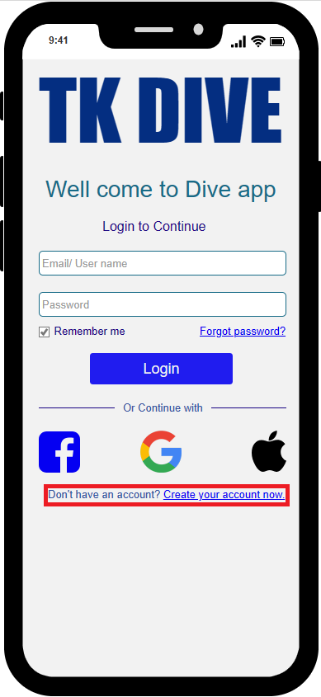

Figure 14: "Create your account now" link

Register design as shown in Figure 12 for creating new accounts. Users input First name, Last name, Email, Username, Password, then click “Register” to complete the process. Existing users can return to the Login design by clicking “Login here”.

Figure 15: Register design

The system prompts an error message as shown in Figure 16 if any field is left blank, the email is invalid, or if the passwords do not match, asking the user to re-enter.

Figure 16. Error message of Register Design

After the user successfully registers an account, the user will be redirected to Login Design to log in to the application.

**Home page:**

After successfully registering and logging in, the user will be redirected to the application's Home page, as shown in Figure 17. The home page displays information such as time, location, achievements that the user has achieved and information about the connected physical device.

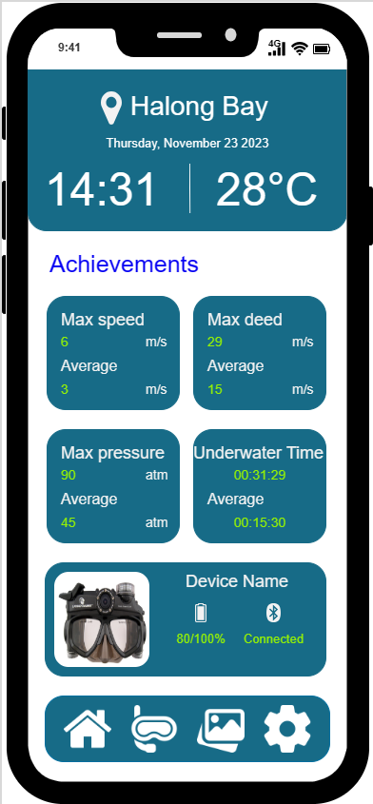

Figure 17:Home page design

**Tracking History:**

To access the Tracking History page as shown in Figure 18, users can click the Tracking icon in the Bottom menu. The Tracking History design showcases all user Dive Tracking, including Track Name, Day, Time, and Max Depth for each track.

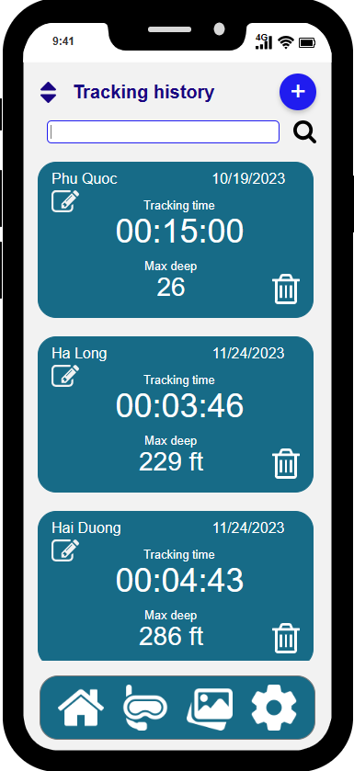

Figure 18: Tracking history design

**At Tracking History design, users can perform various operations presented below:**

**View Track Detail:**

Clicking on any Track directs users to the Track Detail design, revealing comprehensive information recorded during Tracking. This includes displayed photos and videos captured during dives by users, as shown in Figure 19.

Figure 19. Track detail

**Edit Track Name:**

To rename a Track, users click the Edit button beneath the Track name, triggering the display of the "Edit track name" dialog box as show in Figure 20. After entering a new name and clicking "Ok," a confirmation message "Edit Track name successfully!" as shown in Figure 20 appears.

*Evidence of applying the Feedback design principle:* Confirmation message "Edit Track name successfully!" illustrating the application of the Feedback design principle.

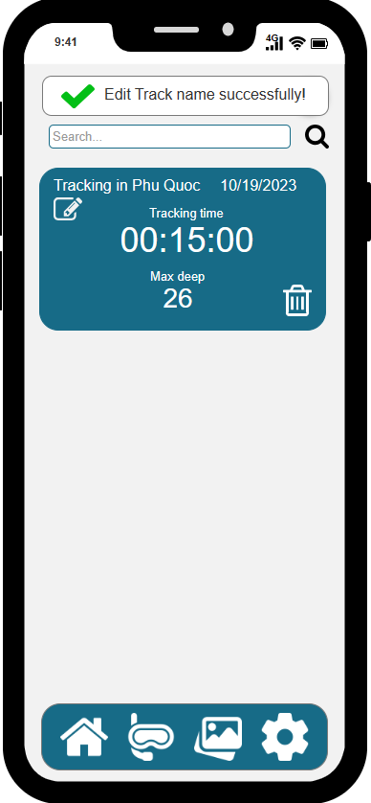

Figure 20: Add new Track

**Delete Track:**

To delete a Track, users can click the trash can icon. A confirmation dialog box will appear as shown in Figure 21, prompting users to confirm deletion by clicking 'Delete' or cancel by clicking “Cancel”. Successful deletion prompts a confirmation message as shown in Figure 21.

*Evidence of applying the Constraints design principle:* The app employs Confirm delete dialog boxes to prevent accidental deletion of Tracks, showcasing Constraints design.

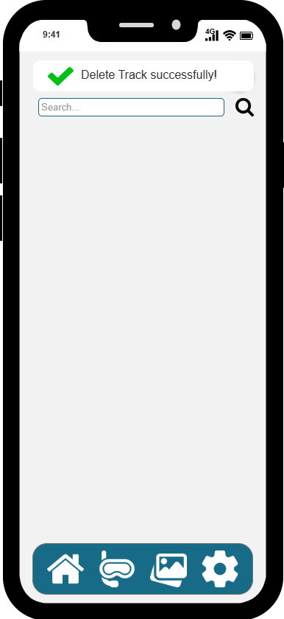

Figure 21. Delete Track

**Add New Tracking:**

Add New Tracking design is a design that allows users to track their diving trip, by recording parameters such as Tracking time, Current depth, Air left in tank, Time gose up, and Dive speed.

Figure 22: Add new track design

**Taking Photos Design:**

During the diving process, users can also switch to Taking Photos Design by touching the Camera icon as shown in Figure 23 in the upper right corner Add New Tracking Design. When the user presses the capture button, the photo will be saved to the gallery. User can also Image taken in each Track.

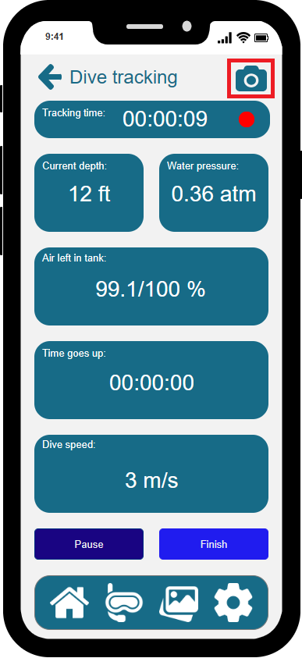 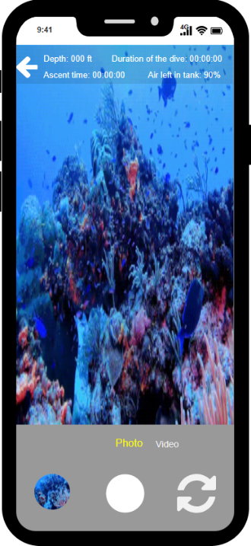

*Figure 23. TakingPhotos design*

**Taking Video Design:** Users can seamlessly switch between capturing photos and recording videos by utilizing the mode switch button located below, demonstrated in Figure 24. Upon successful conversion, the Tacking Video design appears, as depicted in Figure 24. User can also review videos taken in each Track.

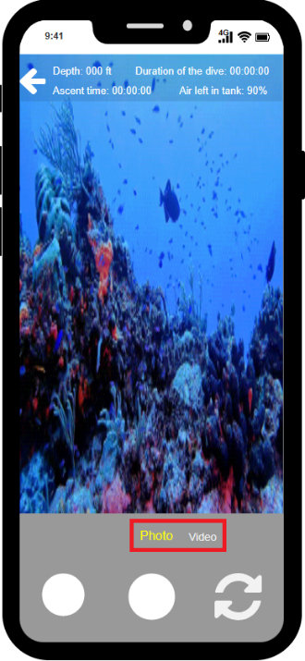

Figure 24: Tacking videos design

**Gallery Design:**

After capturing photos and videos, users access the Gallery design as shown in Figure 25 using the bottom navigation bar's gallery icon. Here, they can view all media captured during dives and explore details by clicking on each, as shown in Figure 25.

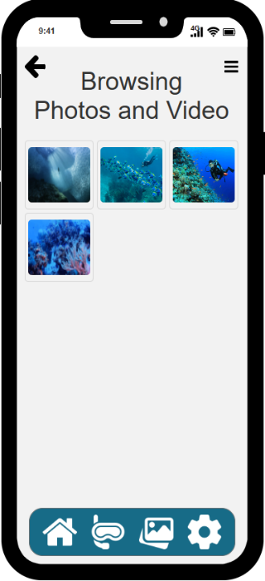

Figure 25: Gallery design

**Setting design:**

The Setting design as shown in Figure 26 allows users to access login details, Profile editing, Change password, connection setups (Wi-Fi, Mobile Internet, Bluetooth), Help User and About App pages, as well as options to Logout and Exit.

Figure 26: Setting design

*Evidence of applying the Visibility design principle:* Setting design presents all user-customizable settings on the design, simplifying user interaction and customization within the interface.

**Edit profile design:**

In Settings, users edit their profile via the "Edit" button in the Profile block. TK DIVE restricts modifications to Avatar and Full name, warning users to re-enter missing data. After entering all information, users confirm changes by pressing the Confirm button, as show in Figure 27.

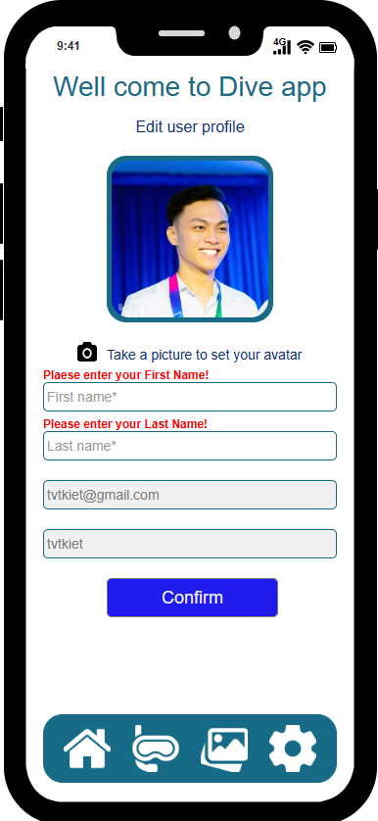

Figure 27. Edit user profile

Edit profile successfully, as shown in Figure 28

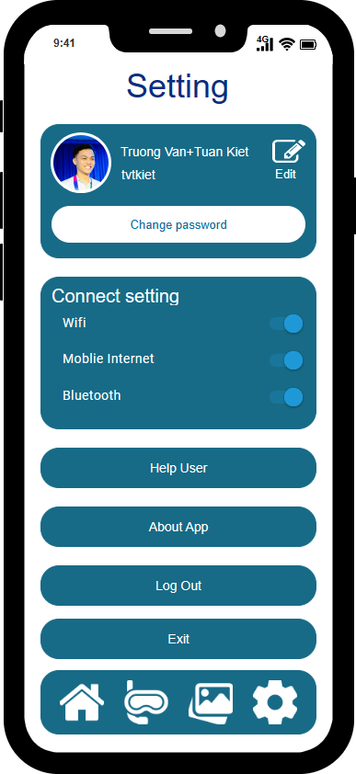

Figure 28. Edit profile successfully

**Change Password design:**

Users access the Change Password design as shown in Figure 29, to update their password by entering the old and new password and confirming the change. The application displays an error message for incorrect entries as shown in Figure 29 and inalizes the change upon clicking “Change Password”.

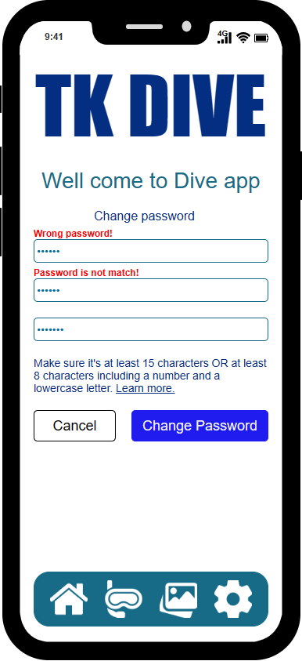

Figure 29. Change Password

**Help user design:**

Help User design provides assistance and guidance within the app interface, offering users information and support for navigation and features, as shown in Figure 30.

Figure 30: Help user design

**About app design:**

About App design offers concise information about the application's purpose, version details, and related information for user reference, as shown in Figure 31.

Figure 31. About app design

*Evidence of applying the Consistency design principle:* TK DIVE app consistently uses 1 background color, 1 font throughout the design process, and the same logo in every design.

*Evidence of applying the Constraints design principle*: Consistent placement of the navigation bar at the bottom and back buttons in the top left across all designs demonstrates the application of the Mapping design principle.

* 1. **Describe the physical prototype**

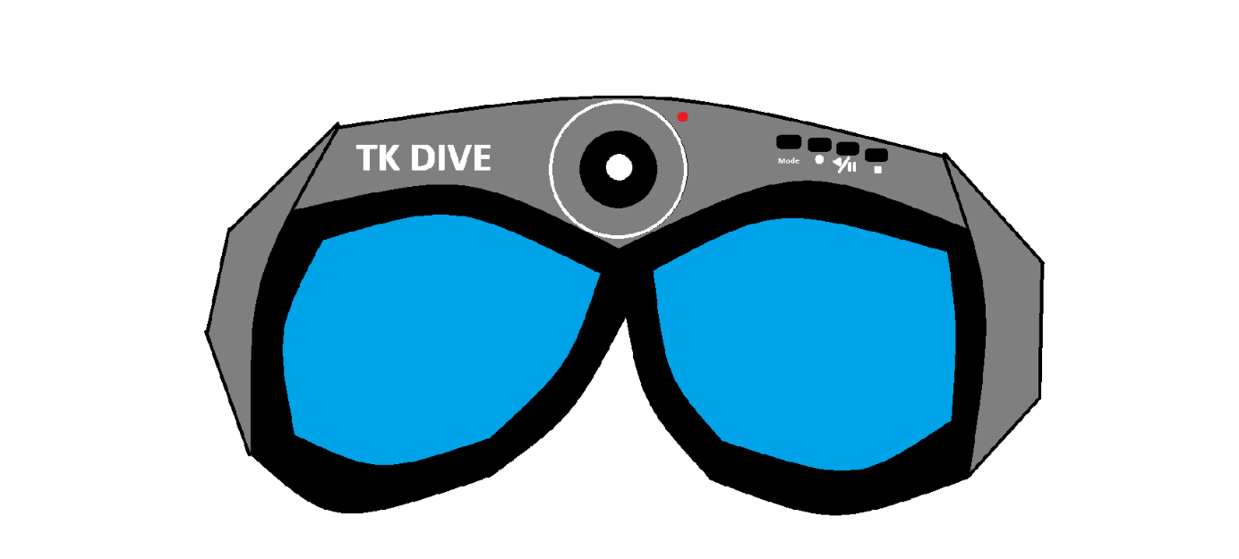

Figure 32. Frontal physical prototype

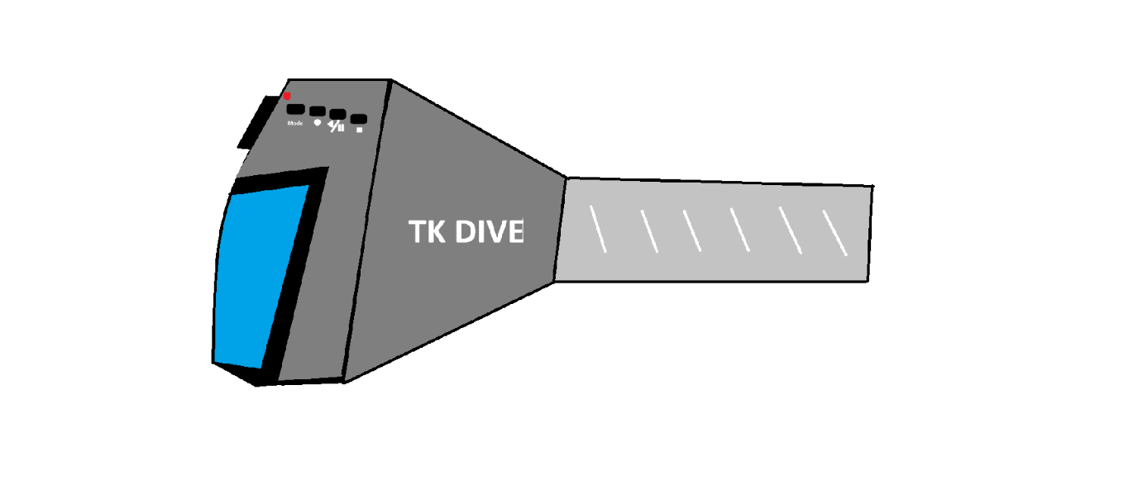

Figure 33. Side physical prototype

The depicted physical prototype Figure 32 and Figure 33 is a diving monitor connecting to the TK DIVE app via Bluetooth. Worn for comfort during dives, it features a forehead camera for high-quality videos and images. Users power the device by holding the "Mode" button, indicated by a flashing red light when active. Controls on the device's forehead cluster manage diving activity tracking, signified by blue for tracking, yellow for pause, and red for stop. A double press on the "Mode" button toggles photography modes; the "Play" button captures photos, and a triple press enables video recording with standard camera functionalities.

# Research Study

To demonstrate the reliability of the TK DIVE project, I conducted a study consisting of two main hypotheses:

* **Hypothesis 1:** "TK DIVE has designed a user-friendly interface to create an intuitive underwater diving experience for users.”
* **Hypothesis 2:** "TK DIVE primarily provides tracking and reporting features for underwater dives, helping users efficiently monitor and manage their diving experiences.”

**Ensuring Research Reliability and Data Accuracy: A Rigorous Approach**

Ensuring research reliability and precision demands a methodical approach. This entails rigorous data collection, validated tool utilization, and consistent analysis methods. Transparent research procedures and ethical compliance are pivotal for credibility. Our approach involved meticulous participant selection, mixed data collection methods, and strict analysis protocols to achieve these standards.

**Participant Selection: A Quest for Expertise and Relevance**

A rigorous participant selection process was undertaken to evaluate the credibility and practicality of the TK DIVE project. By leveraging targeted engagement strategies within scuba diving communities on Facebook, a diverse pool of eight individuals was carefully recruited. Each participant possessed a minimum of two years of diving experience, ensuring a deep understanding of underwater environments and equipment requirements. The group comprised an equal representation of four men and four women, spanning an age range from 20 to 50 years. This strategic selection aimed to gather varied perspectives and comprehensive feedback from a representative sample of scuba divers, encompassing different genders, age groups, and experience levels. The targeted engagement approach proved effective in reaching potential participants who aligned with the project's target audience, providing valuable insights into the usability, functionality, and overall appeal of the TK DIVE application.

**A Blend of Qualitative and Quantitative Methods: Unraveling Complexities**

In the Course Work pursuit of a comprehensive assessment of the TK DIVE app, the Course Work employed a diverse array of data collection methods, blending qualitative and quantitative approaches. This strategic fusion allowed the Course Worrk to gain a comprehensive view, exploring both the nuanced experiences of participants and the quantifiable aspects of their interactions. Through specific quantitative inquiries detailed in Table 2, the Course Work measured factors such as user perception of equipment ease-of-use, satisfaction with training, and overall diving experience enjoyment. These metrics revealed patterns and trends, offering insights into the app's effectiveness. Alongside quantitative data, qualitative questions were employed to capture subjective user experiences and insights, allowing for a deeper understanding of individual motivations, challenges faced, and overall satisfaction with the app.

**Data Analysis: Unveiling the Essence of Information**

After meticulous data collection, the Coursework rigorously analyzed the information to ensure its integrity and accuracy. Quantitative data underwent thorough statistical analysis to unveil significant patterns and relationships among variables, forming a robust basis for understanding the TK DIVE app's effectiveness. Meanwhile, qualitative data was subject to thematic analysis, enabling us to categorize participant responses and identify recurring themes. This method allowed us to delve into user sentiments and experiences, providing valuable insights into their perspectives.

**Conclusion: A Commitment to Rigor**

Throughout the exploration of the TK DIVE app, the commitment to upholding reliability and precision in the findings has been unwavering. This commitment has steered the participant selection, defined the methods for data collection, and guided the procedures for data analysis.

Starting the Research Study, I let participants experience the TK DIVE application and asked them to participate in the survey I created using Google form, as shown in Table 2.

Table 2: Hypotheses Questions

|  |  |  |
| --- | --- | --- |
| **No.** | **Hypothesis** | **Questions** |
| 1 | TK DIVE has designed a user-friendly interface to create an intuitive underwater diving experience for users. | 1. What were your initial feelings when you started using the TK DIVE application?  2. Is the interface of the TK DIVE application easy to use?  3. Can you quickly find and access settings or customization options in the TK DIVE app?  4. Did the interface's design and layout enhance or hinder your ability to capture memorable moments during your dives?  5. What is your brief comment on the interface of TK DIVE application? |
| 2 | TK DIVE primarily provides tracking and reporting features for underwater dives, helping users efficiently monitor and manage their diving experiences. | 1. Does TK DIVE's dive tracking feature help you track your underwater diving effectively?  2. Did you find it easy to switch between capturing photos and recording videos using the TK DIVE interface?  3. Have you used TK DIVE tacking photo and video recording features to record your underwater diving progress?  4. While using TK DIVE, has the tracking and reporting feature helped you improve your underwater diving skills or make better decisions about your dive?  5. What is your brief comment on the interface of TK DIVE application? |

This research study used Google Forms to conduct this survey. It saved me time and cost. The questionnaire can be found in Appendix 1, and the results of the questionnaire analysis are provided in Appendix 2.

# Conclusion

**Conclusion:**

The Diving Tracking project culminates in a commendable achievement, presenting a user-friendly diving application and device that significantly enrich the underwater exploration journey. This innovative solution adeptly tracks diving activities, ensuring precise recordings of depth, time spent underwater, and air consumption. The integrated photography and video recording features further empower users, allowing them to effortlessly capture and share cherished underwater moments. Despite its successes, certain limitations and constraints are evident, necessitating attention.

**Limitations and Constraints:**

The current prototype's reliance on Bluetooth for communication, while reliable, presents limitations in range, particularly for deep-sea or remote underwater exploration. Ergonomic enhancements are imperative to improve comfort, especially during prolonged diving sessions. The study's sample size, though informative, is limited, highlighting the necessity for a more expansive and diverse participant pool to holistically grasp user preferences and refine functionality. Valuable insights from experienced divers and instructors could offer invaluable direction for refining the app's usability and functionality.

**Areas for Improvement:**

Strategic enhancements can propel the Diving Tracking app and device to new heights. Implementing long-range communication technologies such as Lora WAN or Wi-Fi mesh can significantly extend the device's connectivity range, enabling seamless communication even in remote underwater environments. Refining the device's design to accommodate various head sizes and shapes will bolster comfort, catering to the needs of diverse users and prolonged usage scenarios.

**Potential Next Steps:**

The TK DIVE project presents promising avenues for future development. Creating a high-fidelity prototype will facilitate comprehensive testing and detailed user feedback, enabling meticulous refinement of the app's interface and the device's design. Conducting more extensive research with a broader and more diverse sample of divers will deepen the understanding of user requirements and preferences. Additionally, exploring integration possibilities with wearable devices and diving computers holds substantial potential for enriching the app's capabilities and offering users a more integrated and immersive diving experience.

# References

Fang Chen & Jacques Terken, 2022. Interaction Design Theory. In: *Automotive Interaction Design.* s.l.:Springer, Singapore, pp. 129-144.

Abrar, M., 2023. *The Application of Cognitive Psychology to User-Interface Design.* [Online]   
Available at: https://www.loop11.com/the-application-of-cognitive-psychology-to-user-interface-design/

Benyon , D., 2004. *Designing interactive systems.* 3 ed. s.l.:Pearson Prentice Hall.

Chen, F. & Terken, J., 2023. *Automotive Interaction Design.* s.l.:Springer Singapore.

Cooper, A., Reimann, R., Cronin, D. & Noessel, C., 2014. *About Face: The Essentials of Interaction Design.* s.l.:John Wiley & Sons, Inc., Indianapolis, Indiana.

Deepblu, 2023. *ABOUT DEEPBLU.* [Online]   
Available at: https://about.deepblu.com/diving-community/  
[Accessed 2023].

Dive Plus, 2023. *Dive Plus.* [Online]   
Available at: http://www.dive.plus/  
[Accessed 2023].

Divemate, 2023. *Divemate.* [Online]   
Available at: https://www.divemate.de/  
[Accessed 2023].

Dumas, J. & Redish, J., 2007. *A practical guide to usability testing.* s.l.:Indiana University Press.

Eysenck, M. & Keane, M., 2020. *Cognitive Psychology A Student's Handbook.* s.l.:Psychology Press.

Folmer, E., 2023. *Interaction Design Patterns.* [Online]   
Available at: https://www.interaction-design.org/literature/book/the-glossary-of-human-computer-interaction/interaction-design-patterns

Jurafsky, D. & H. Martin, J., 2007. *Speech and Language Processing.* s.l.:Prentice Hall.

Lazar, J., Feng, H. J. & Hochheiser, H., 2017. *Research Methods in Human-Computer Interaction.* 2nd ed. s.l.:Morgan Kaufmann Publisher.

Norman, D., 2014. *The Design of Everyday Things.* s.l.:The MIT Press.

Sharp, H., Preece, J. & Rogers, Y., 2019. *Interaction Design: Beyond Human-Computer Interaction.* s.l.:John Wiley & Sons, Incorporated.

Sharp, H., Rogers, Y. & Preece, J., 2019. *Interaction design beyond human-computer interaction.* Indianapolis, Indiana: Wiley.

Shneiderman, B. & Plaisant, C., 2004. *DESIGNING THE USER INTERFACE.* NewYork: Pearson Education.

Warfe, Z. T., 2009. *Guide, Prototyping: A Practitioner's.* s.l.:s.n.

# Appendices 1 - The questionnaires in the Survey of users about TK DIVE aplication

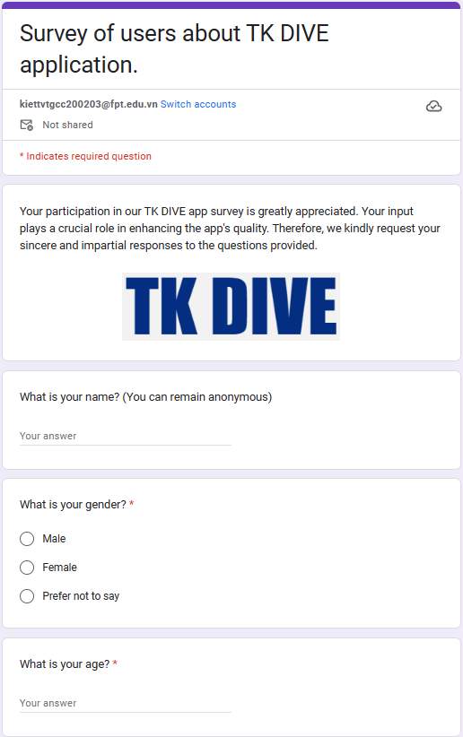

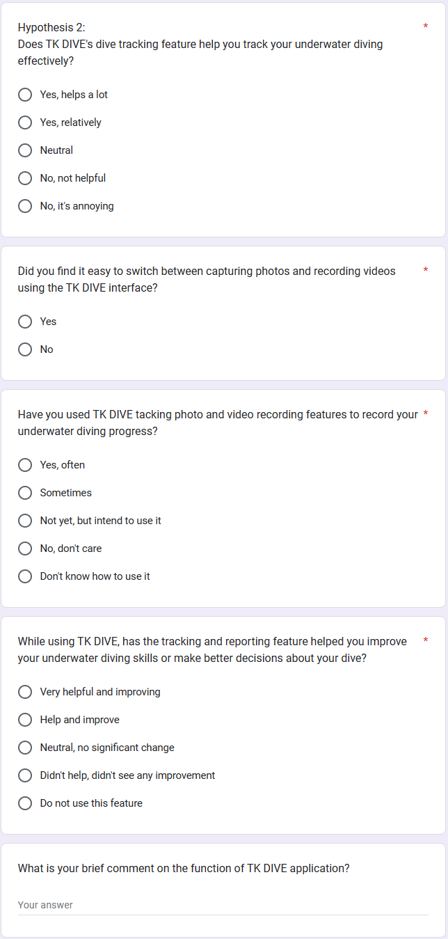

# Appendices 2 - Analyze the results of the questions in the survey and draw conclusions for each hypothesis that has been raised.

* **The survey link of the Survey of users about TK DIVE aplication**

Survey link: <https://forms.gle/FtEkJ9AGKv673CTm9>

* **Analysis of the survey results**
* **Result of question 1:** Based on the chart analysis as shown in Figure 30, 75% of users expressed feeling very positive upon commencing app usage, while the remaining 25% indicated a positive sentiment. This reflects a generally positive emotional response among all users at the start of their app experience.

Forms response chart. Question title: Hypothesis 1
What were your initial feelings when you started using the TK DIVE application?. Number of responses: 8 responses.

Figure 34. Question 1 of the Survey

* **Result of question 2:** Based on the chart analysis, 75% of users find the interface of the TK DIVE application easy to use, while 25% use the remote interface. This suggests that most users perceive the TK DIVE application interface as user-friendly.

Forms response chart. Question title: Is the interface of the TK DIVE application easy to use?
. Number of responses: 8 responses.

Figure 35: Question 2 of the Survey

* **Result of question 3:** Based on the chart analysis, 100% of users indicated that they can easily locate and access settings or customization options within the TK DIVE app. This demonstrates the exceptional intuitiveness and ease of use in the Setting design.

Forms response chart. Question title: Can you quickly find and access settings or customization options in the TK DIVE app?
. Number of responses: 8 responses.

Figure 36. Question 3 of the Survey

* **Result of question 4:** Based on the chart analysis, 100% of users expressed that the design and layout of the interface significantly enhanced their capacity to capture memorable moments during their diving experiences. This substantiates the ease of use in the Photo and Video Recording design.

Forms response chart. Question title: Did the interface&apos;s design and layout enhance or hinder your ability to capture memorable moments during your dives?
. Number of responses: 8 responses.

Figure 37. Question 3 of the Survey

* **Result of question 5:** Based on the chart analysis as shown in Figure 34, 75% of users believe that TK DIVE's diving tracking feature helps a lot in monitoring their underwater activities, while 25% find it relatively. Overall, the feedback suggests that all users find the feature beneficial for monitoring their diving activities underwater.

Forms response chart. Question title: Hypothesis 2:
Does TK DIVE&apos;s dive tracking feature help you track your underwater diving effectively?
. Number of responses: 8 responses.

Figure 38. Question 5 of the survey

* **Result of question 6:** Based on the chart as shown in Figure 35, 87.5% of users frequently used TK DIVE's photo and video recording features to document their underwater dives, while 12.5% used these features occasionally. This demonstrates that most users utilize TK DIVE's video and photo recording functionalities for documenting their underwater experiences.

Forms response chart. Question title: Have you used TK DIVE tacking photo and video recording features to record your underwater diving progress?
. Number of responses: 8 responses.

Figure 39. Question 6 of the survey

* **Result of question 7:** Based on the chart analysis, 100% of users found it easy to switch between capturing photos and recording videos using the TK DIVE interface. This indicates that the Tacking Photo and Video function is user-friendly and easy to navigate, as shown in Figure 36.

Forms response chart. Question title: Did you find it easy to switch between capturing photos and recording videos using the TK DIVE interface?
. Number of responses: 8 responses.

Figure 40. Question 6 of the survey

* **Result of question 8:** Analysis of the chart reveals that 75% of users find the tracking and reporting feature in TK DIVE Very helpful and improving, aiding in enhancing their underwater diving skills or aiding in decision-making. Meanwhile, 25% consider it Help and improve. Overall, all users agreed that the tracking and reporting feature significantly improved their diving skills or decision-making processes, as show in Figure 37.

Forms response chart. Question title: While using TK DIVE, has the tracking and reporting feature helped you improve your underwater diving skills or make better decisions about your dive?
. Number of responses: 8 responses.

Figure 41. Question 8 of the survey

* **Conclition:**
* **Hypothesis 1:**

Through the results of the data analysis process, Hypothesis 1 is strongly supported, confirming that TK DIVE has effectively designed a user-friendly interface. The intuitive nature of the interface greatly enhances the underwater diving experience for the user. Positive user feedback and engagement metrics underscore TK DIVE's success in prioritizing user experience, ensuring accessibility, and promoting a seamless and enjoyable interface for enthusiasts. loves diving. Overall, the evidence gathered firmly confirms the hypothesis, highlighting TK DIVE's commendable efforts in creating an intuitive interface for underwater exploration.

* **Hypothesis 2:**

Through meticulous data analysis, Hypothesis 2 finds strong validation, emphasizing TK DIVE's central focus on offering robust tracking and reporting functionalities for underwater diving activities. The comprehensive features integrated within TK DIVE facilitate effective monitoring and management of diving experiences. The gathered evidence vividly illustrates the platform's commitment to empowering users with tools for comprehensive dive tracking and reporting, affirming TK DIVE's dedication to enhancing the diving experience through advanced monitoring capabilities.

1. https://www.divemate.de/
2. https://about.deepblu.com/
3. http://www.dive.plus/